The traffic phase estimation has required careful observation of the traffic signals in order to abstract the many possible phase variations into a more consistent, less complex system that still resembles reality to a high extent. Using the data provided by the City of Magdeburg, as well as in-person observation and recording, the team has agreed to proceed with a phase chages system as described in Table (below) along with Durations. We have fixed the duration of each phase by taking the average of Observed Phase duration.We have also verified with the data from City of Magdeburg. Each cycle is for 90 sec.

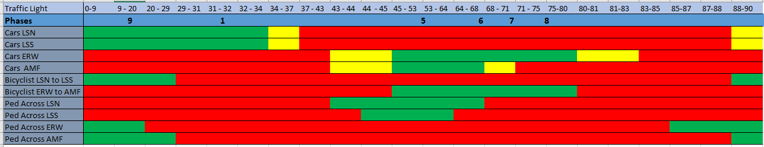 **Table 13:** Summary of traffic light phase analysis results

The possible traffic phases for the node is mentioned in the figure below.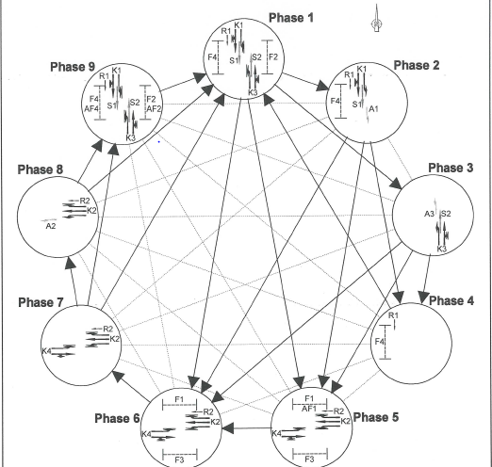

We observed that during peak hours it followed phase transition cycle of

9 🡪1 🡪5🡪6🡪7 🡪8 🡪9.We have modelled our traffic lights accordingly .Since the duaration of these phases are not equal for the opposite lanes we had to use separate traffic light for each lane and they were all modelled according to the durations mentioned in the table 13.Pedestrian behaviour is controlled by separate pedestrian traffic light for each line which works synchronously with Car Traffic Light .